**ABSTRACT**

The Food Delivery System provides online real time information about the food items available in the Menu and the user information. The main purpose of this project is to reduce the contact between the customer and the waiter.The purpose of this project is to provide a friendly environment to order food during the COVID-19 pandemic to maintain contactless interactions in a restaurant. The required software and hardware are easily available and easy to work with. It can lead to error free, secure, reliable and fast management systems .This software is capable of managing Food Search, Food Orders . The customer can search and order his favourite food item from the cuisine of his choice from the menu by using the search function. This Food Delivery System has been designed to fill a specific niche in the market by providing small restaurants with the ability to offer their customers an online ordering option without having to invest large amounts of time and money in having custom software designed specifically for them.

This project is divided into two categories: Admin and Client-Side. In an overview of this web application, the user can simply look for available food items from the client-side. The website displays the top 3 food categories with recent food items. The customers can search for their own items too.

**TABLE OF CONTENTS:**

1. Title Page Abstract ………………………………………………………………… 3
2. Table of Contents………………………………………………………………….. 4
3. List of Abbreviations ……………………………………………………………… 5
4. List of Figures …………………………………………………………………….. 5
5. List of Tables ……………………………………………………………………… 5

1. Introduction ……………………………………………………………………. 9

2. Problem definition ……………………………………………………………… 9

3. Database Design (ER diagram) ………………………………………………… 10

4. GUI (Screen Shots) with client side validations ………………………………… 11

5. PhP Session Handling details ………………………………………………….. 16

6. Conclusions ……………………………………………………………………. 18

7. Bibliography in IEEE format ………………………………………………….. 19

8. Appendix ……………………………………………………………………… 20

a. Tools used

b. References

**LIST OF ABBREVIATIONS**

|  |  |  |
| --- | --- | --- |
| 1. | HTML | Hyper Text Markup Language |
| 2. | SQL | Structured Query Language |
| 3. | PHP | Hypertext Preprocessor |
| 4. | CSS | Cascading Style Sheet |
| 5. | XAMPP | X (cross platform), Apache, MySQL, PHP, Perl |
| 6. | GUI | Graphical User Interface |
| 7. | ER | Entity Relationship Diagram |

**LIST OF TABLES**

|  |  |
| --- | --- |
| 1. | Admin |
| 2. | Category |
| 3. | Food |
| 4. | Order |

**LIST OF FIGURES**

|  |  |
| --- | --- |
| 1. | ER Diagram |

**LIST OF TABLES:**

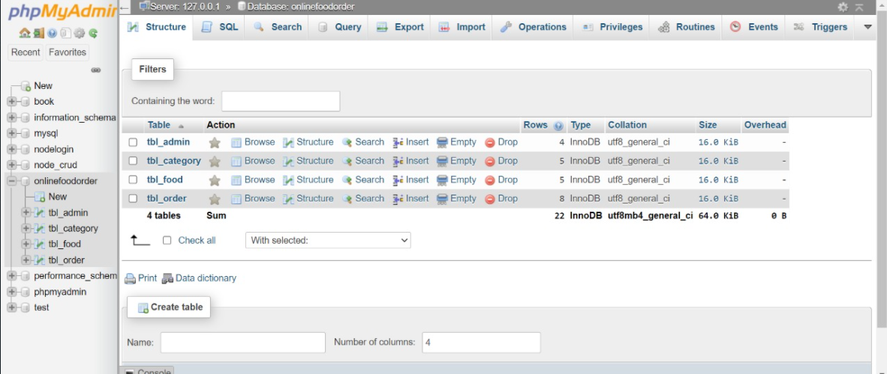

**TABLE 1 : Admin**

* Admin_id
* Full_name
* Usernam
* Password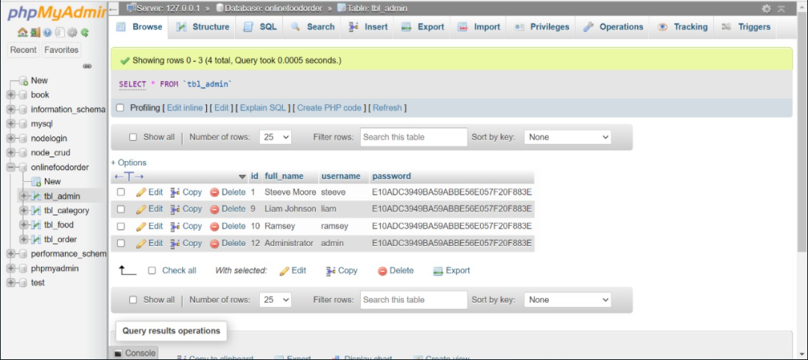

**TABLE 2 : Category**

* Category_id
* Title
* Image_name
* featured
* active

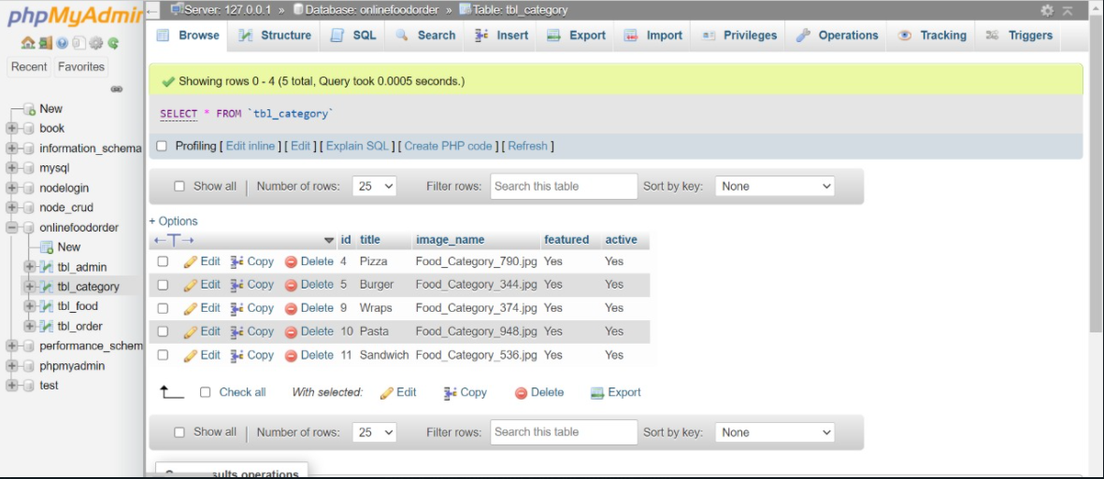

**TABLE 3 : Food**

* Food_id
* Title
* Description
* Price
* Image_name
* Category_id
* featured
* active

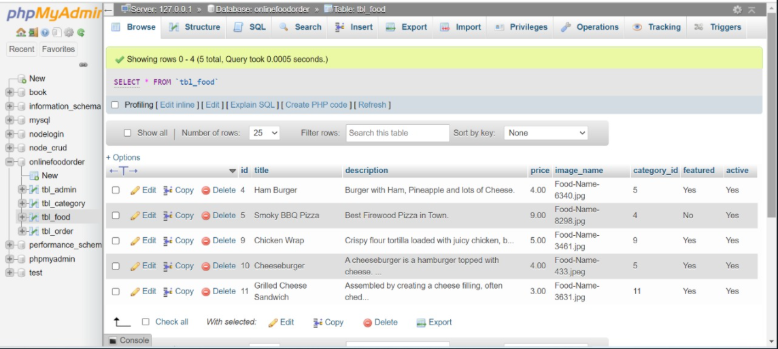

**TABLE 4 : Order**

* Order_id
* Food
* Price
* Quantity
* Total
* Order_date
* Status
* Customer_name
* Customer_Contact
* Customer_email
* Customer_address

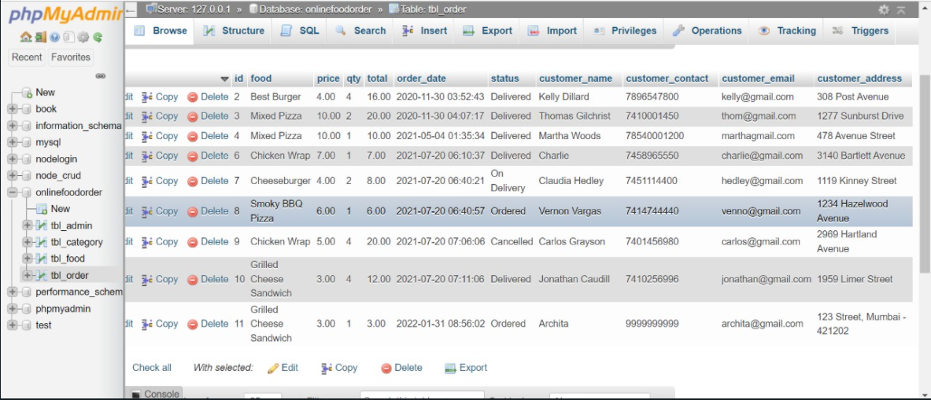

**INTRODUCTION**

The project Food Delivery system is a web based application that allows the administrator to handle all the activities online quickly and safely.Our proposed system is a Food Delivery system that enables ease for the customers. It overcomes the disadvantages of the traditional queueing system. Our proposed system is a medium to order online food hassle free from restaurants as well as mess service. This system improves the method of taking orders from customers. The Food Delivery system sets up a food menu online and customers can easily place the order as per their wish. Also with a food menu, customers can easily track the orders.

The main purpose of this project is to reduce the contact between the customer and the waiter. This software is capable of managing Food Search and Food Orders. The customer can search and order his favourite food item from the cuisine of his choice from the menu by using the search function.

**Functionalities provided :**

* Online Food Ordering
* Manage the information of Food Categories
* Manage the information of Food Items
* Food Order Management
* System User Management
* The system provides search, request and modify orders.
* Editing, adding and updating of Records is improved which results in proper resource management of Food Item data
* Total Revenue
* Overview Data

**Problem Statement**

Food Delivery System for contactless placement of order in a restaurant. A customer can order food in a restaurant without a waiter. The customer will be shown the menu with various cuisines to order. Based on the order, the food will be delivered to the customer to their table .

**Database Design**

ER DIAGRAM :

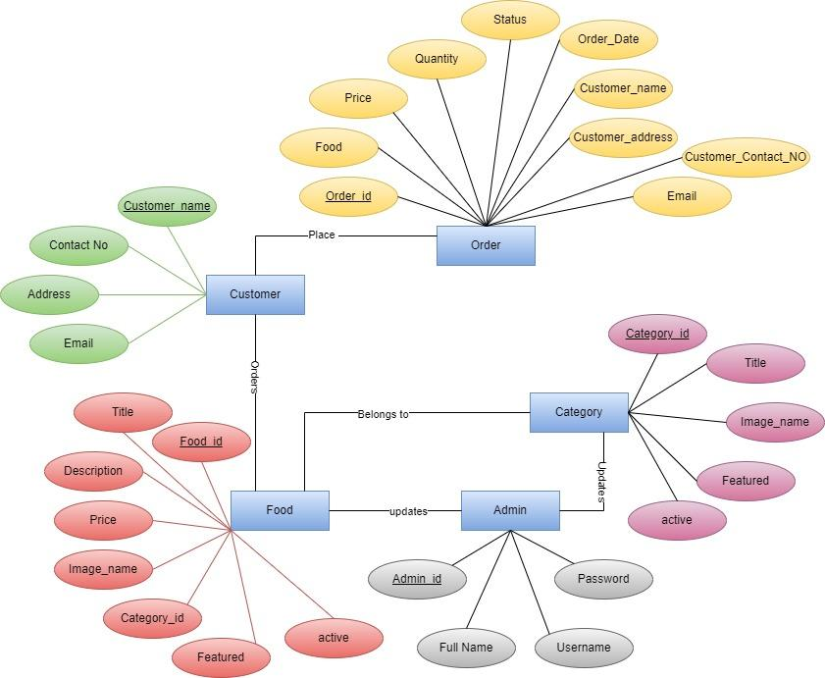

**GUI (Screen Shots) with client side validations**

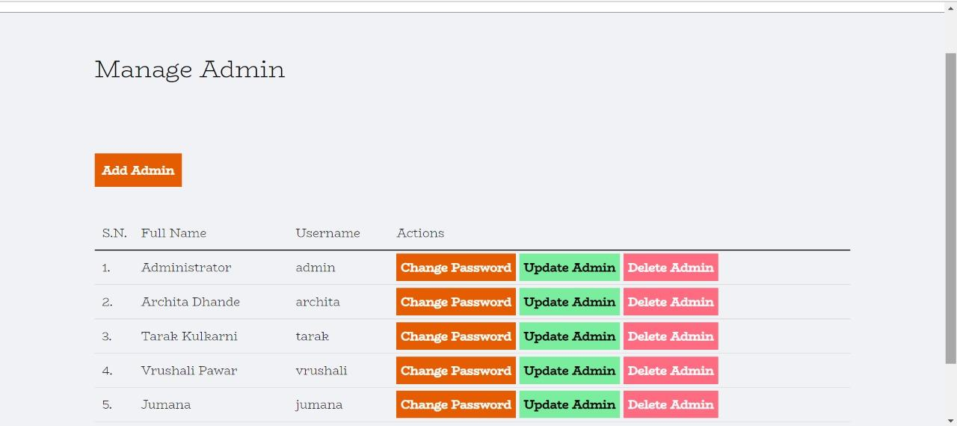

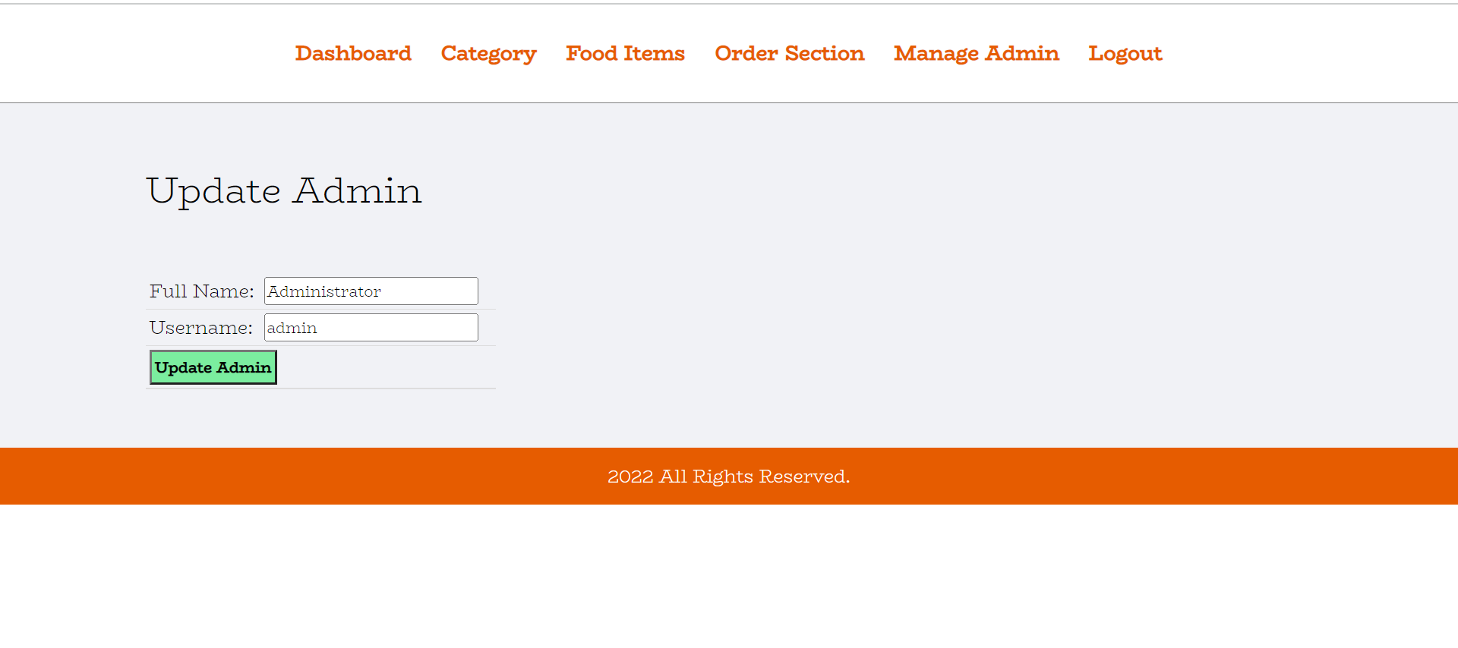

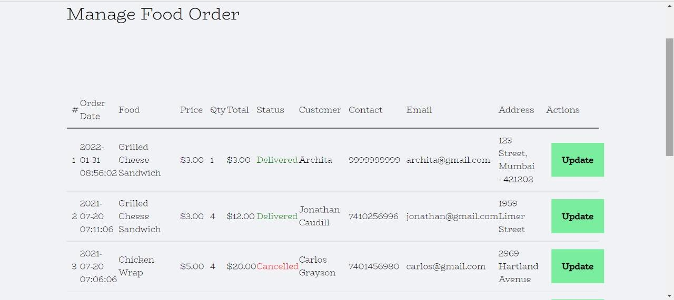

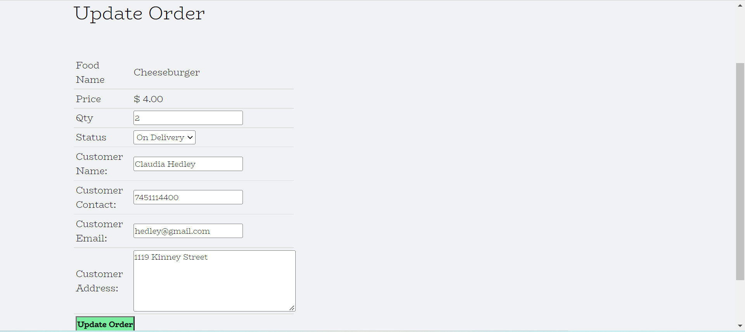

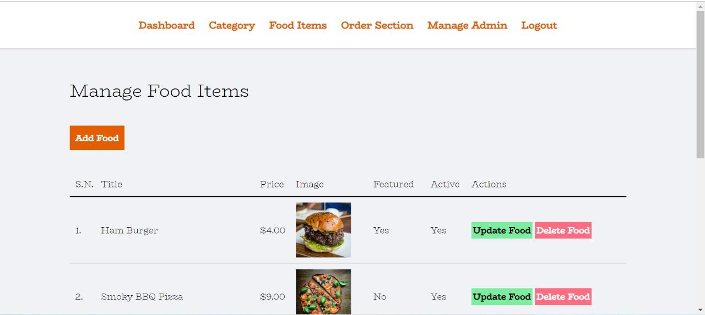

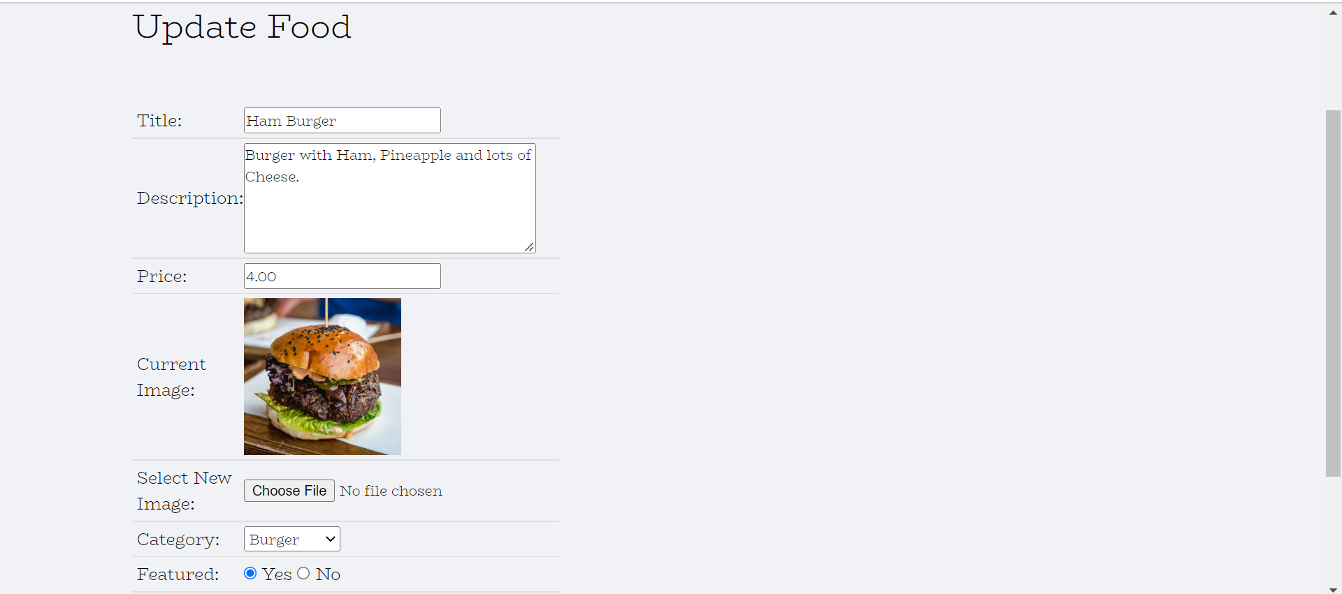

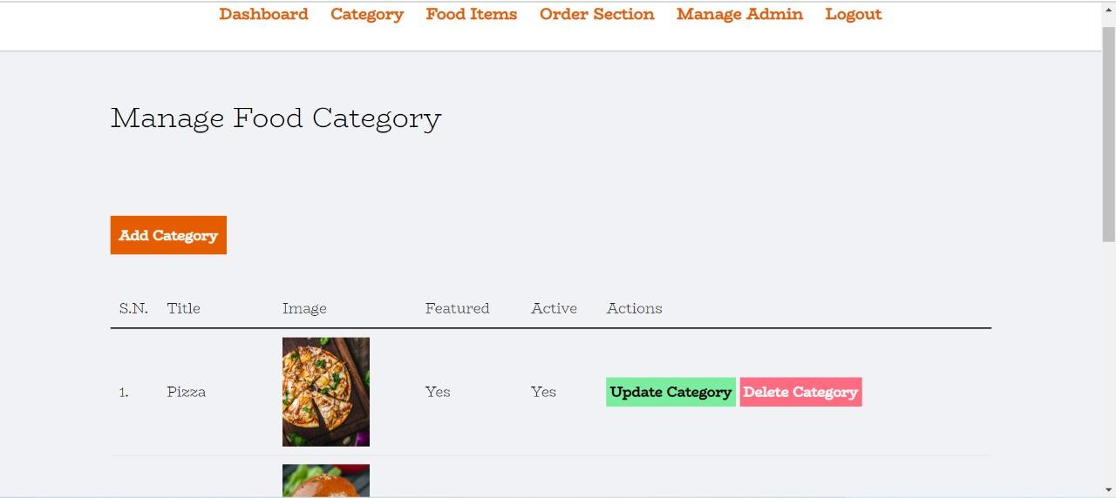

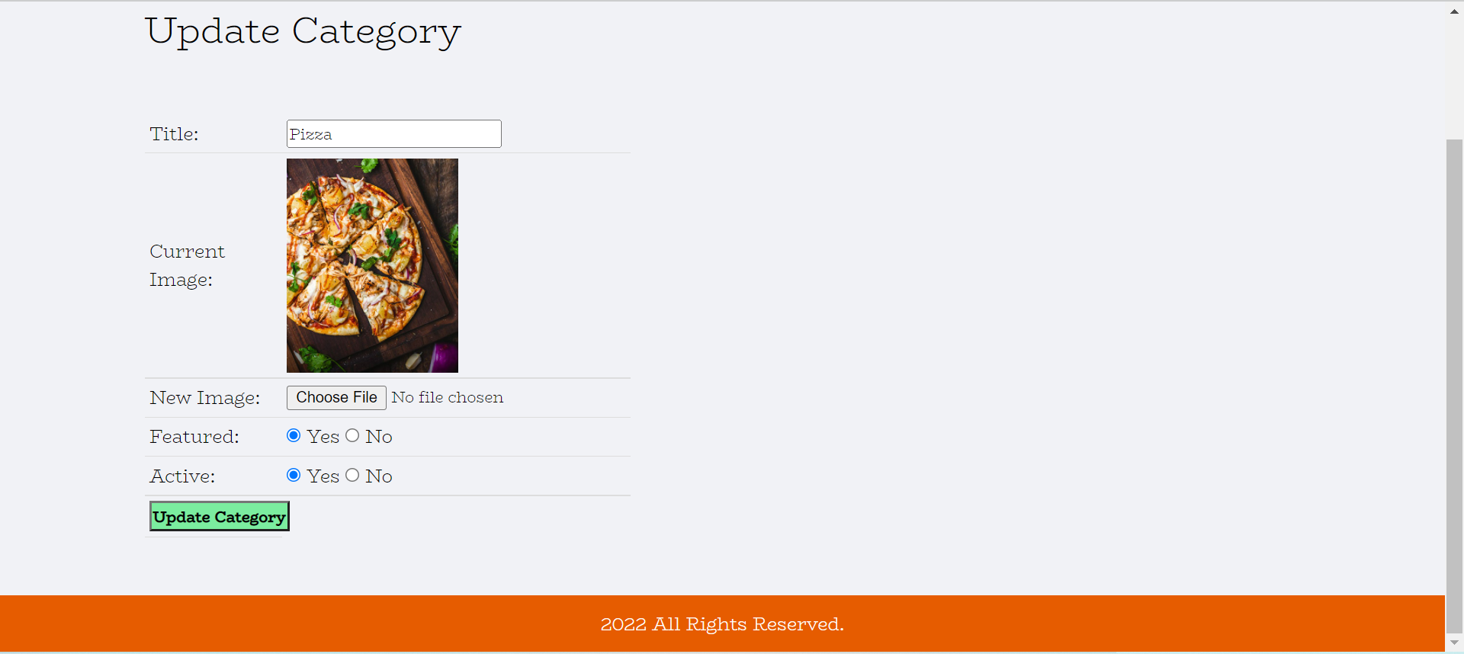

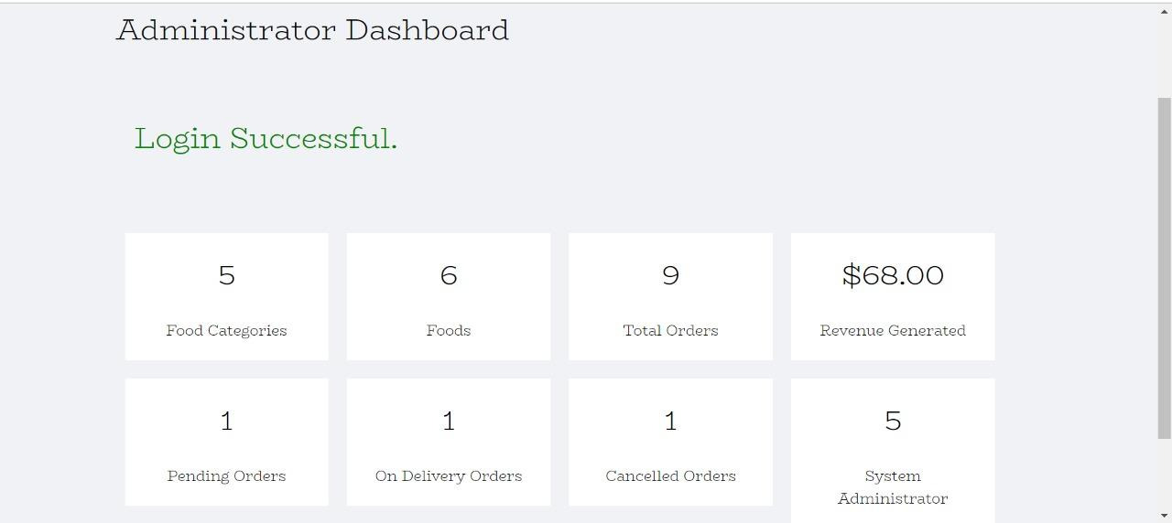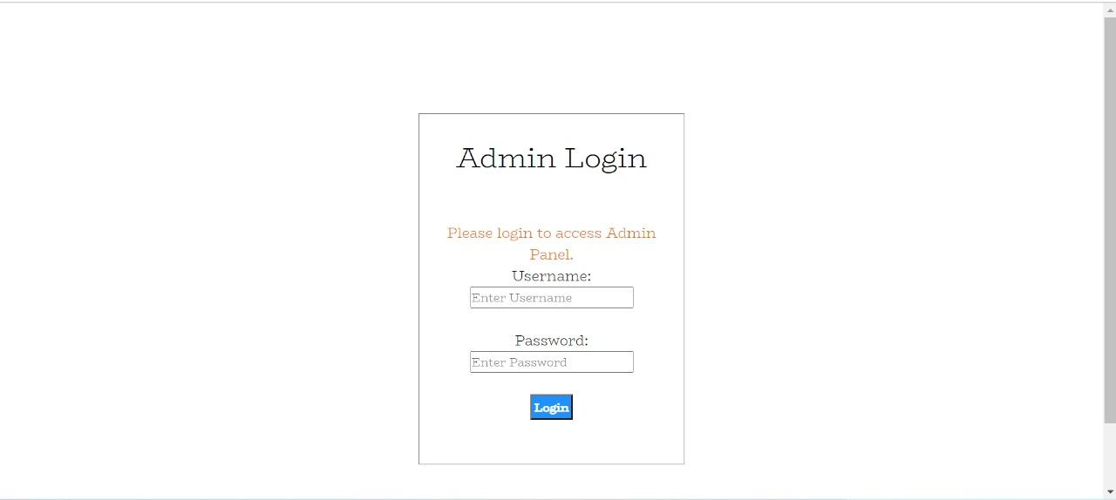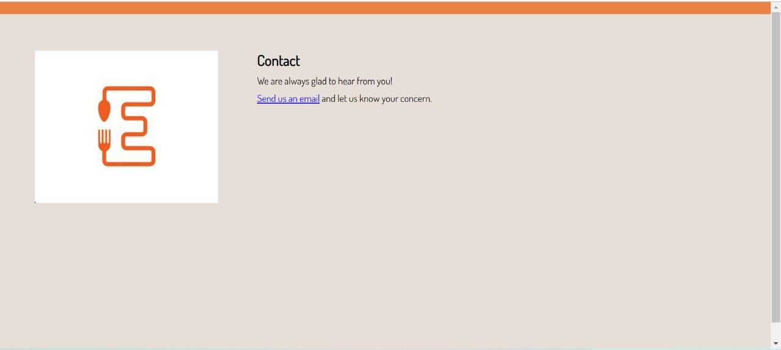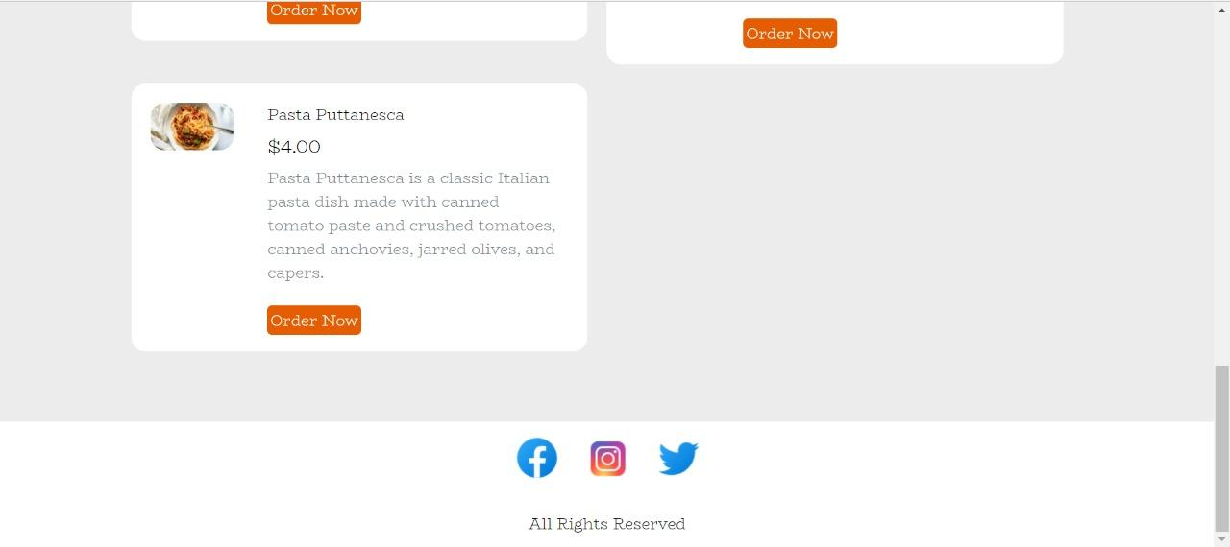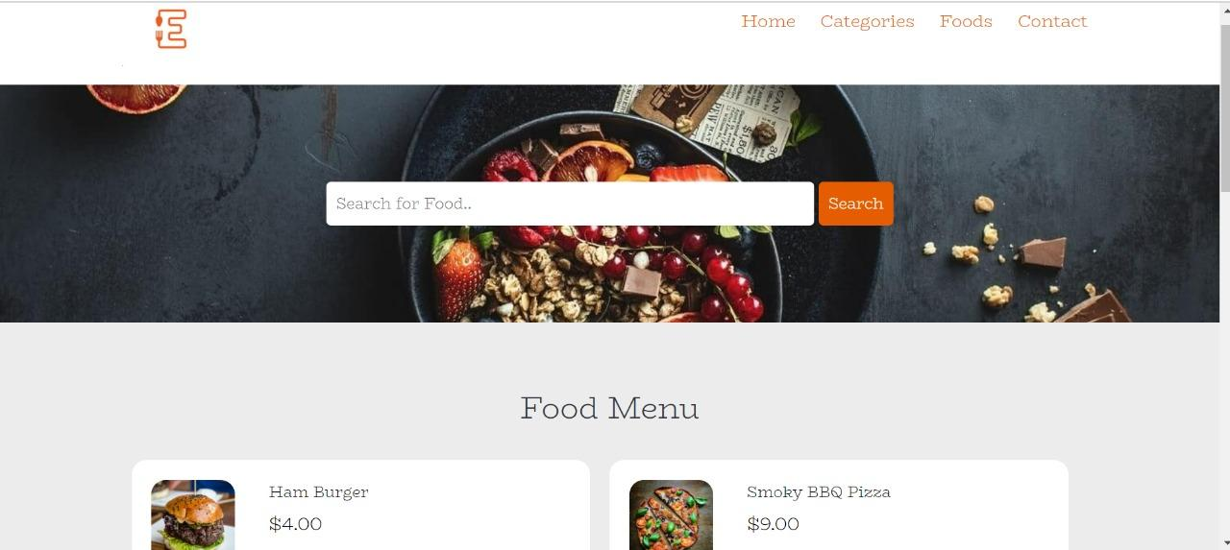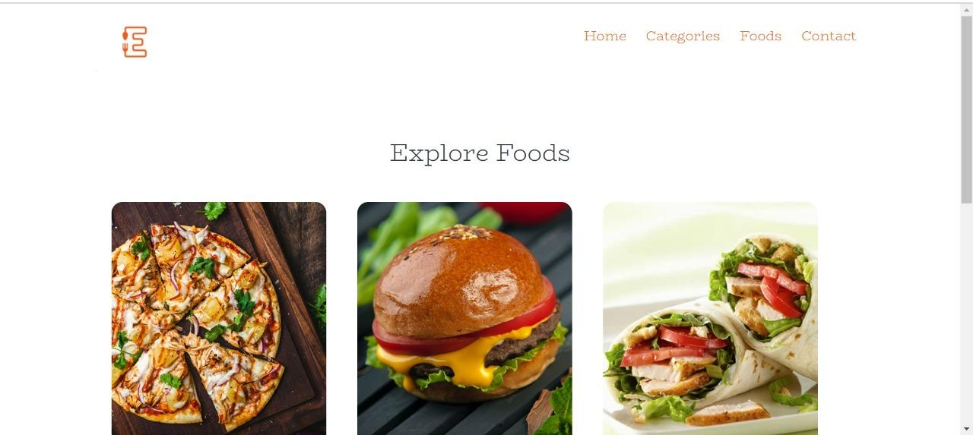

**PhP Session Handling**

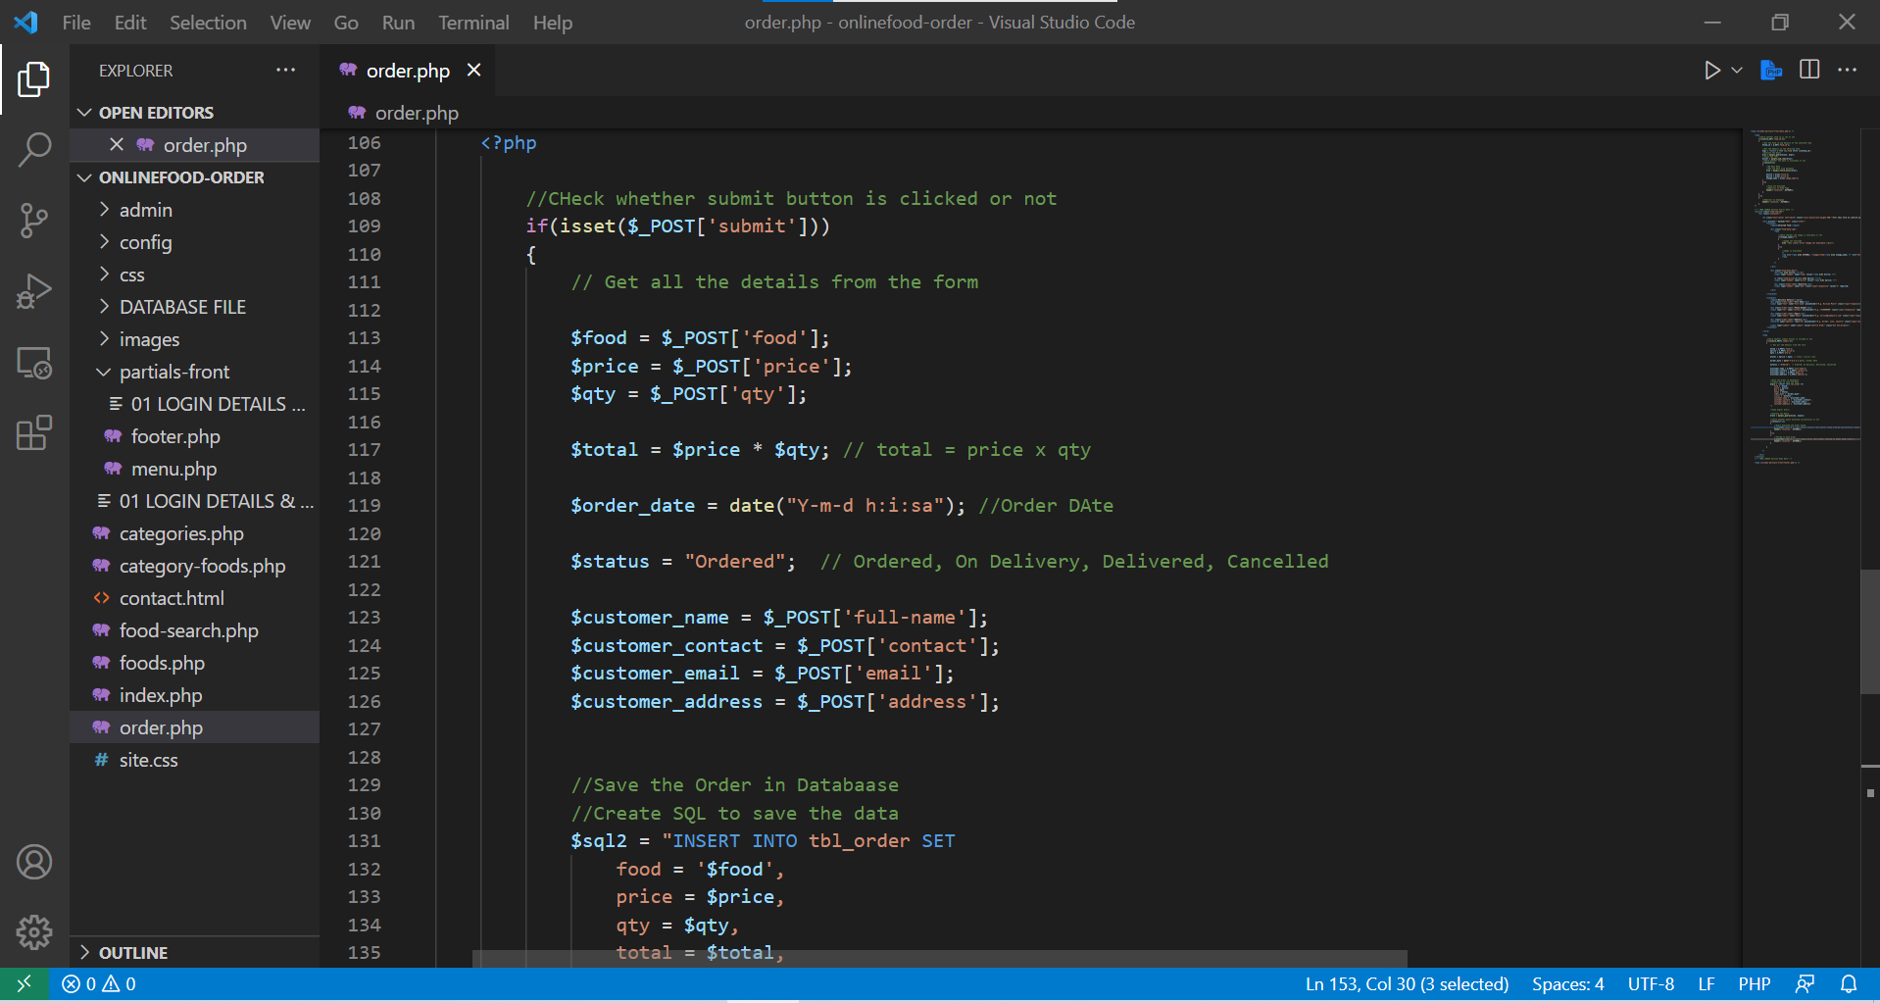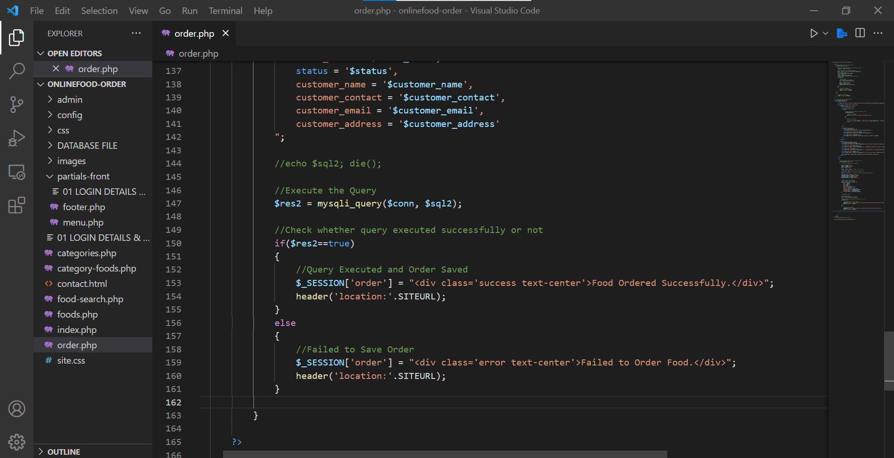

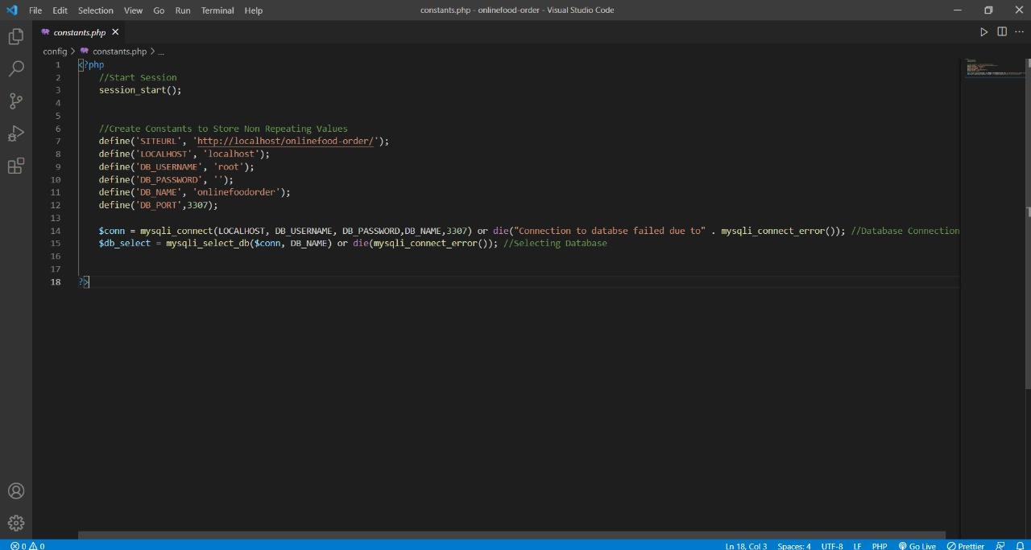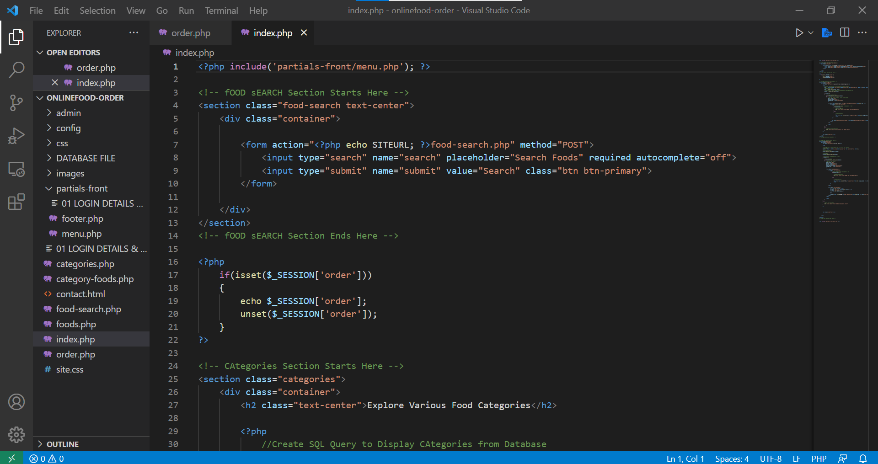

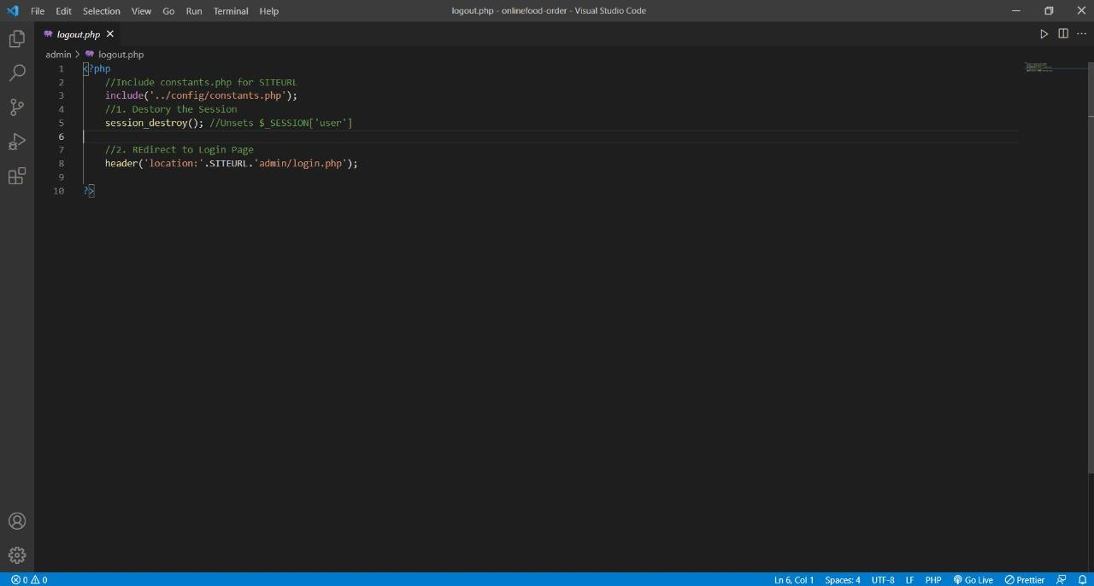

**Conclusion**

Hence, we completed our mini project and created a website for Food Delivery System by

using HTML, CSS, PHP, MySQL and JavaScript.

**Bibliography**

* <https://www.geeksforgeeks.org/design-a-webpage-for-online-food-delivery-system-using-html-and-css/>
* <https://www.w3schools.com/php/default.asp>
* <https://www.google.com/search?q=fast+food+images&tbm=isch&ved=2ahUKEwjHxIS4tvX1AhWyRGwGHZryAOwQ2-cCegQIABAA&oq=fast+food+images&gs_lcp=CgNpbWcQAzIICAAQgAQQsQMyBQgAEIAEMgUIABCABDIFCAAQgAQyBQgAEIAEMgUIABCABDIFCAAQgAQyBQgAEIAEMgUIABCABDIFCAAQgAQ6BAgAEEM6BggAEAcQHlDuCViZI2C5JmgAcAB4AIABsgGIAdkGkgEDMC43mAEAoAEBqgELZ3dzLXdpei1pbWfAAQE&sclient=img&ei=wysFYofXA7KJseMPmuWD4A4&bih=569&biw=1280>
* <https://www.w3schools.com/PhP/php_sessions.asp>

**APPENDIX**

TOOLS AND TECHNOLOGIES

* PHP
* MySQL
* HTML
* CSS3
* Sassy CSS
* XAMPP - Local Server
* Phpmyadmin - SQL GUI Manager
* Javascript
* VSCode

**REFERENCES**

* [PHP MySQLi Functions (w3schools.com)](https://www.w3schools.com/php/php_ref_mysqli.asp)
* [CSS: Cascading Style Sheets | MDN (mozilla.org)](https://developer.mozilla.org/en-US/docs/Web/CSS)
* [PHP: Documentation](https://www.php.net/docs.php)
* [SCSS: Sassy Cascading Style Sheets (sharkcoder.com)](https://sharkcoder.com/tools/scss#:~:text=SCSS%20%28Sassy%20CSS%29%20is%20a%20CSS%20preprocessor%2C%20an,variables%20%28%24%29%2C%20and%20the%20same%20assignment%20sign%20%28%3A%29.)
* [MySQL :: MySQL Documentation](https://dev.mysql.com/doc/)